**Chapter 11: The economy in the long run: an introduction to economic growth**

**Medium and long run business cycle differences:**

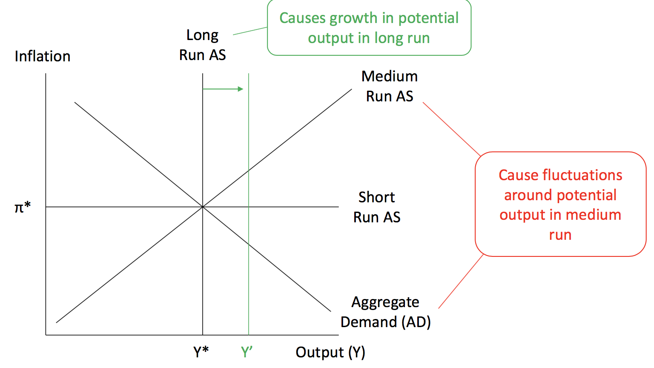

**Factors of production**:

* Output is driven by labour, land, capital, and technology

1. Labour: The number of people

It is the most important factor because it involves people.

1. Land: The amount and quality of land, natural resources, waterways, etc
2. Capital:

* Human: The talent/education/skills of labour
* Physical: The physical tools labour uses

1. Technology (ability to combine existing things in a clever way)

* Inventions: combining capital
* Institutions (eg. lawyers) : combining labour

Colonialism: Europeans left good institutions where settler mortality was low, and extractive institutions where it was high

1. Inclusive institution: everyone has a say
2. Extractive institution: decided by the powerful person

* Management: combining capital and labour

**Average labour productivity**

* 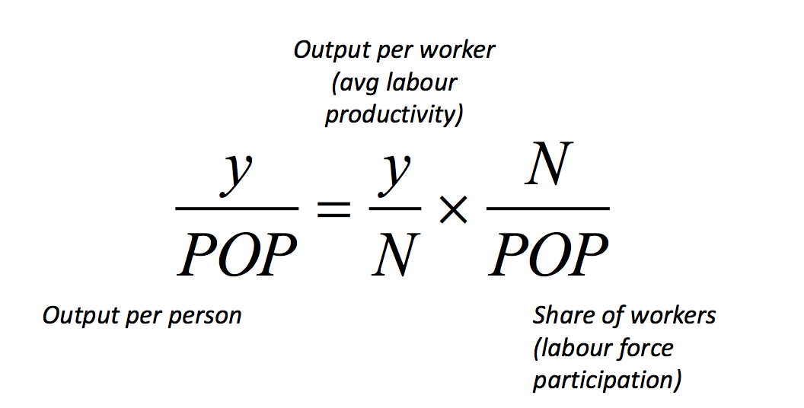
* Average labour productivity in Australia has consistently risen throughout history, increasing income per person
* Labour force participation has also risen due to women entering into the workforce and improve in health (so that people work longer and retire later), but not as much.

**Policies on the factor of production**

1. Labour

* Baby bonuses/one child policies/immigration
* Healthcare, higher retirement ages
* Women’s empowerment

1. Land

* Colonialism/war
* Trade

1. Capital

* Saving current production, or borrowing (trade-offs)

1. Physical: interest rates, public infrastructure, etc
2. Human: education and training
3. Technology
4. Inventions: public R&D – basic science, tax incentives
5. Institutions: separation of powers, checks and balances
6. Management: Tax incentives, low tariffs (import competition)